# ***Assignment:***

*Module -1: Understanding of Hardware and Its Components*

*Section 1: Multiple Choice*

*1.Which of the following is NOT a component of the CPU?*

*ANS: RAM*

*2.What is the function of RAM in a computer?*

*ANS: The function of ram is to store the data in your computer* and lets you open apps and files quickly

*3. Which of the following is a primary storage device?*

*ANS:*  *HDD and SSD*

*4.What is the purpose of a GPU?*

*ANS:* *It handles the calculations relating to graphics, such as geometry, color, shading, and textures, and frees up the CPU for other tasks*

*Section 2: True or False*

*5.* *The motherboard is the main circuit board of a computer where other components are attached*

*ANS:TRUE*

*6.* : *A UPS (Uninterruptible Power Supply) is a hardware device that provides emergency power to a load when the input power source fails*.

*ANS:FALSE*

*7.An expansion card is a circuit board that enhances the*

*functionality of a component.*

*ANS:TRUE*

*Section 3: Short Answer*

*8. Explain the difference between HDD and SSD.*

*ANS:*

|  |  |
| --- | --- |
| *HDD* | *SDD* |
| ***HDDs store data in magnetic disks****.* | ***SSD store data in flash memory*** |
| *HDD is slower than SDD* | ***SSD are smaller and faster than hard disk drives HDD*** |
| *HDD has removable parts on it* | *SDD does not have removable parts* |

*9. Describe the function of BIOS in a computer system.*

*ANS:BIOS stands for basic input/output system. BIOS identifies, configures, tests and connects computer hardware to the OS immediately after a computer is turned on*

*10. List and briefly explain three input devices commonly used with computers.*

*ANS: There are three input devices commonly used with computer*

*1.mouse*

*2.keyboard*

*3.Microphone*

*1.Mouse: This Is the small input device. when we move the mouse around on a table the pointer on a screen also move. It is used to control the computer. There are 7 types of mouse are available in the market, mechanical mouse, opto mechanical mouse, optical mouse, track ball mouse, track point mouse, touch pad mouse, ergonomic mouse.*

*2.Keyboard: This is an another important input device of the computer it allows you to type letters, numbers, and symbols in your computer. Standard keyboard, laptop keyboard, gaming keyboard, laser keyboard, rollup keyboard these are the various keyboard types.*

*3.Microphone. This is the device that convert sound waves into an electrical signals*

*Section 4: Practical Application*

*11. Identify and label the following components on a diagram of a*

*motherboard:*

*● CPU*

*● RAM slots*

*● SATA connector*

● PCI-E slot

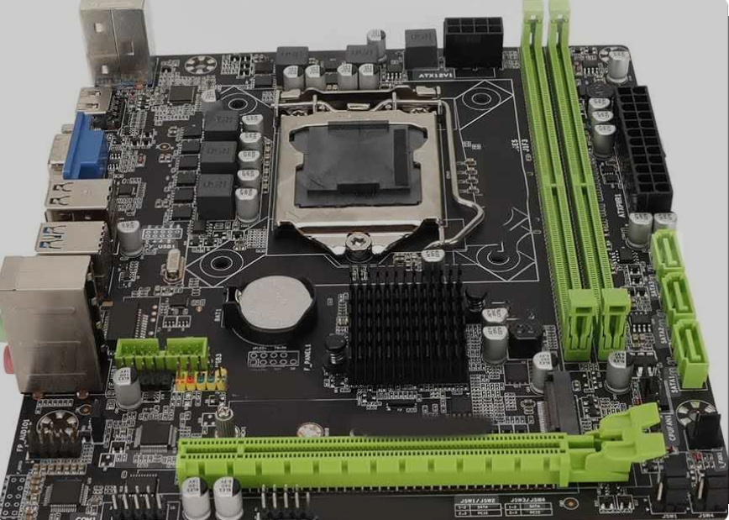

*CPU RAM slots SATA connector*

PCI-E slot

*12. Demonstrate how to install a RAM module into a computer.*

*ANS:*

*There are few steps for installing RAM module into a computer describing below*

1. *Identify the RAM slot on your motherboard*
2. *Push down the locking tabs at the end of the each slots*
3. *Ensuring the notch of the RAM stick match that of the slots*
4. *Push down the RAM stick down.*

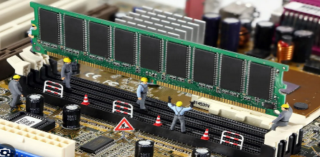

*Section 5: Essay*

*13. Discuss the importance of proper cooling mechanisms in a computer*

*system. Include examples of cooling methods and their effectiveness.*

*ANS:* *Cooling is important for getting the best performance out of any computer system. with Examples for the Solutions*

1. *Heat Management: Computers on the other hand and a likewise computer generates during operation heat, more or less from all parts. If it is not spread correctly, this heat can result in a slow cook of your components over time and low performance.*
2. *Overheating reduces performance in which the components might not get too hot because they start to slow down their speed so that they won't fry themselves, but this slow down can affect the health of the system in long term*
3. *Too much heat can lower the lifespan of certain parts like cpus, gpus, and even hdds/sdds as well. This can also help make your expensive components last longer by keeping temperatures in a safe range.*
4. *When a system is maintained with proper cooling the slow down or break down will reduce and also crashing of system*

*Example of cooling methods are air cooling and water cooling*

*14. Explain the concept of bus width and its significance in computer architecture*

*ANS* *Bus width in computer architecture refers to the number of bits that can be transmitted simultaneously across the bus. It determines how much data can be transferred between components.*

*Significance of Bus Width*

1. *Data Transfer Speed:- When the bus width is large it allows to tranfer more data at once.*
2. *System performance:- The performance of computer is directly affects with bus width.*
3. *Memory addressing:- When bus width is wider it allows larger memory capacities*
4. *Compatibility and upgradability:- Bus width is connected with system compatibility and upgradability. Because new processor or memory modules can't be utilised in old systems and small bus width*